Step1:Create two linux instances,Use the first free linux AMI

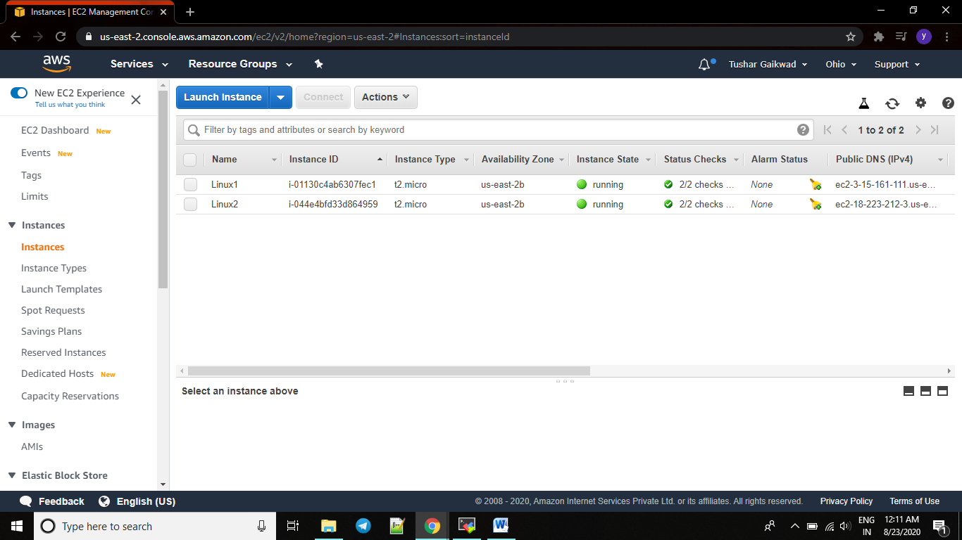

Step2:Launch both instances using Mobaxterm

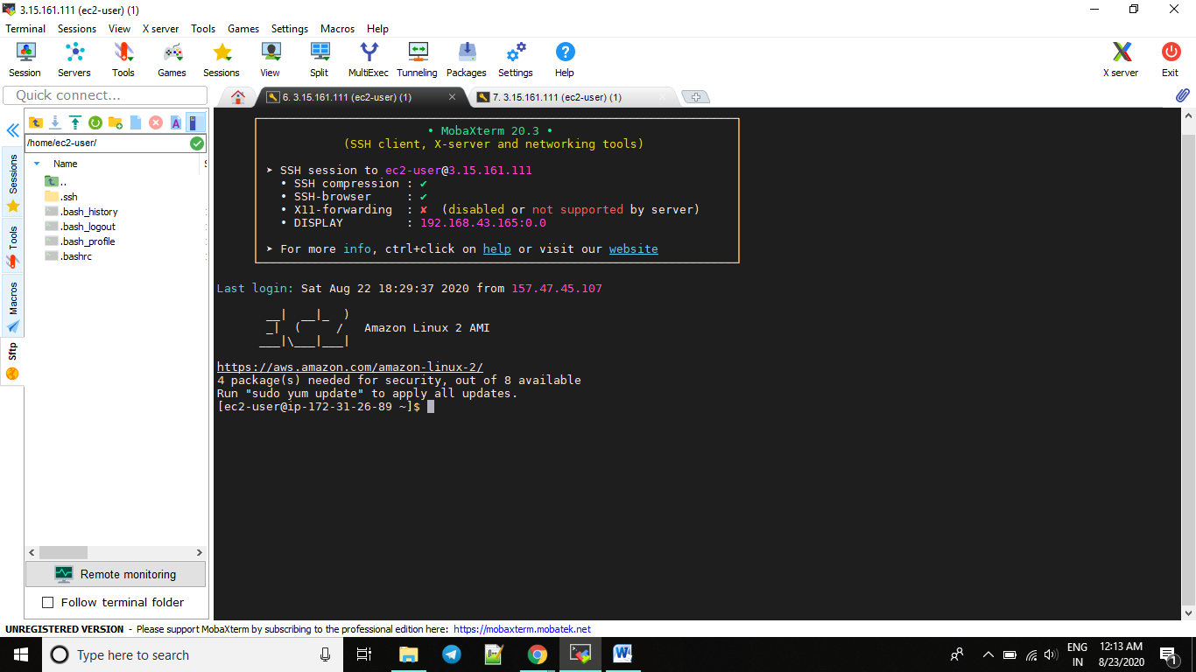

Step4:Host html login webpage on both servers

&

Step5:Check is application is deployed on both servers by copy pasting the public ip of the servers into the browser. <http://3.15.161.111/>

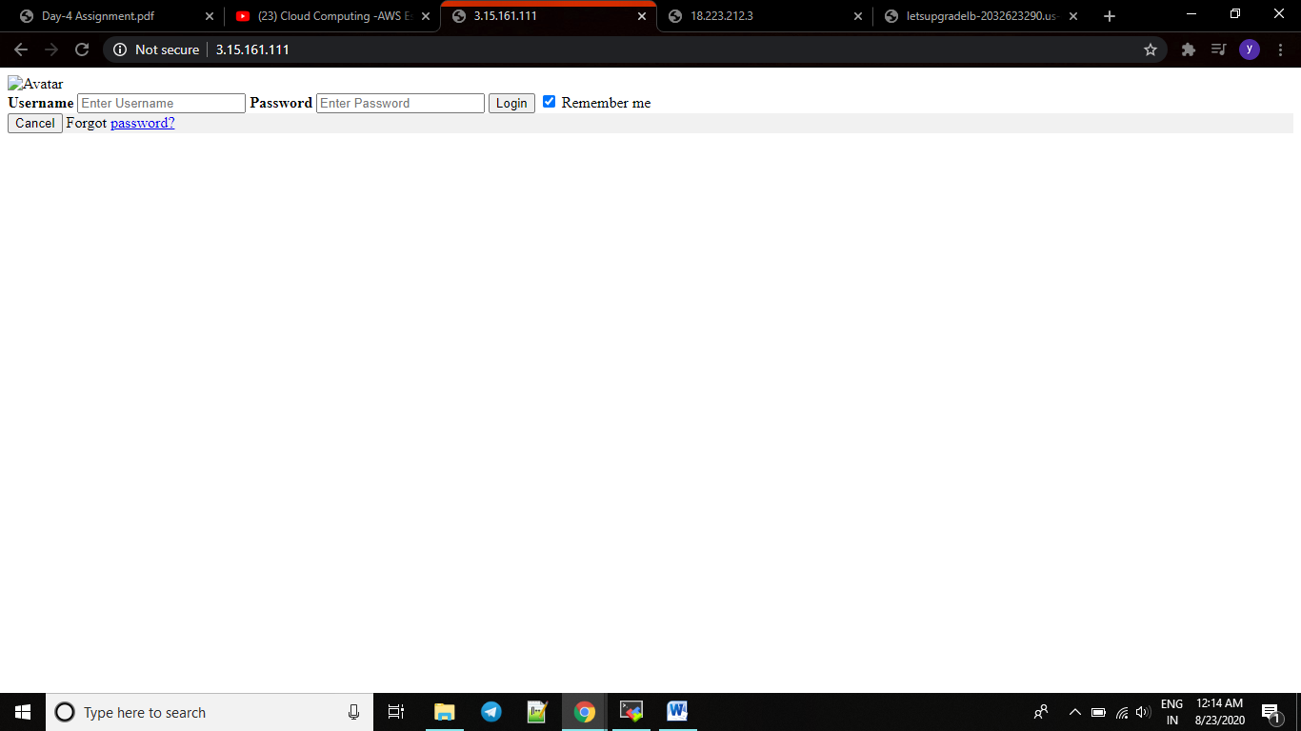

<http://18.223.212.3/>

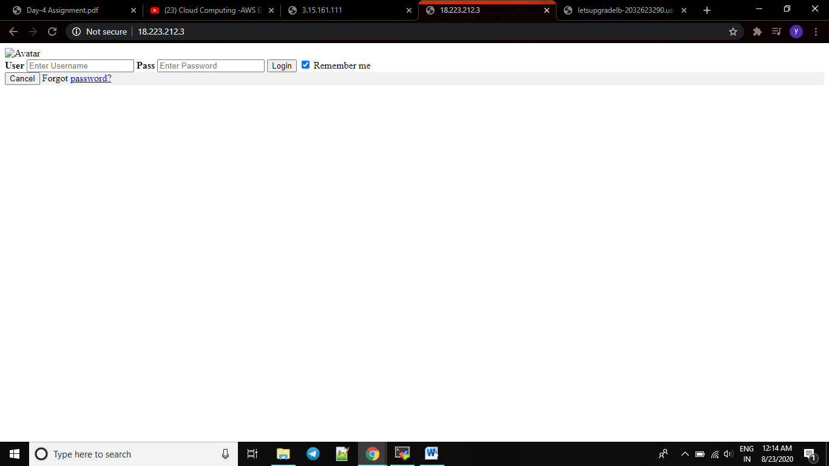

Step6:Create a application Load balancer with the above two instances as targets

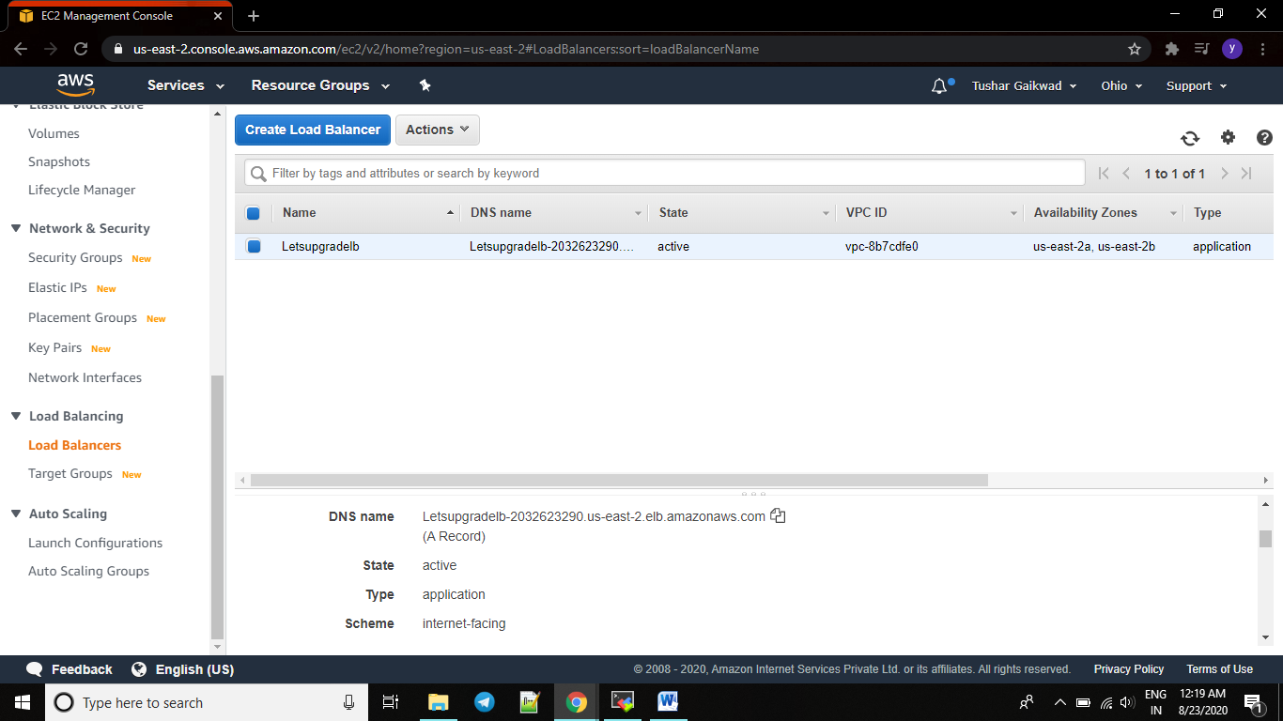

Step7:Check the functioning of ELB

